 | IN MEMORY | 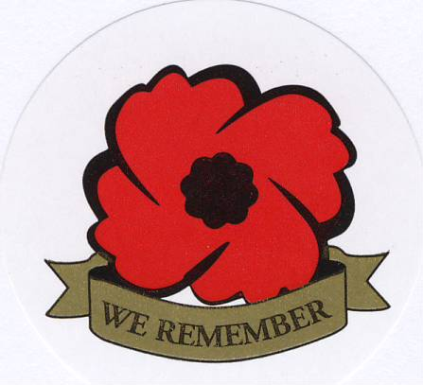

Joan Kathryn McEwen, CD
06 January 1929 - Deceased 2016

Joan McEwen was a Member of the Canadian Association of Veterans in United Nations Peacekeeping and was a member of the National Headquarters Chapter, Ottawa, Ontario.

Joan joined The Royal Canadian Air Force in August 1956 and served until her retirement in December 1978.

Joan completed United Nations tour with United Nations Emergency Force Middle East (UNEFME) from March to September 1976 and United Nations Disengagement Observation Force Golan Heights (UNDOF) from September 1976 to March 1977.

Joan was also a member of the Royal Canadian Legion Branch 97, Oliver, British Columbia and Branch 40 Penticton, British Columbia. She was also a member of the Royal Canadian Air Force Association.

May She Rest in Peace

AT THE GOING DOWN OF THE SUN AND IN THE MORNING, WE WILL REMEMBER THEM

